# Create a Heroku account

1. Sign up for Heroku Set up credentials

# Genereate ssh key

1. This will be done using bash
   1. Open git bash
      1. For Windows – open a folder, right click, and pick Open Git Bash Here.
      2. For Mac - open terminal
   2. ssh-keygen -t rsa -b 4096 -C [your_email@example.com](mailto:your_email@example.com)
      1. use the default file (/h/.ssh/id_rsa). That is, do not put anything in, and just push enter
      2. Do not put a password. That is, just push enter two more times to accept an empty password
      3. *No need to read this, but if you wanted to know what you just did, here is where this is coming from:* [*https://help.github.com/articles/generating-a-new-ssh-key-and-adding-it-to-the-ssh-agent/*](https://help.github.com/articles/generating-a-new-ssh-key-and-adding-it-to-the-ssh-agent/)

# Add the key to heroku

* Using sublime (or another text editor), open the id_rsa.pub file. It should be located at /h/.ssh/id_rsa..
  + Do not use publisher (which is the default)
  + On Mac:
  + (Go to your editor and then to open new file then click command+shift+G and type ‘~/.ssh’ this will take you to your ssh folder and then all you need to do is click on the .pub file)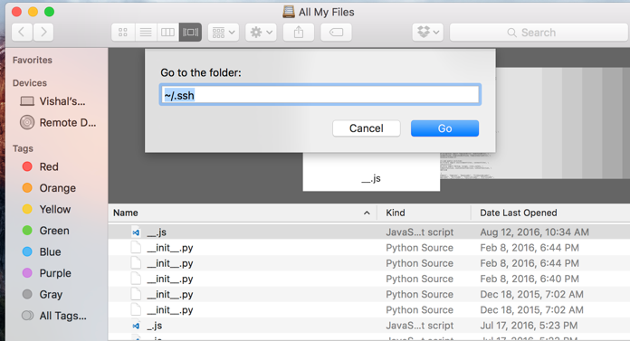
* Copy all of the contents in id_rsa.pub
* <https://dashboard.heroku.com/account>
* Paste this file into the ssh key option located on the herorku web app.



* + The contents should start with ssh-rsa

# Set up on computer

1. Log into heroku on windows cmd (not bash)
   1. On windows: To get there, go to the start menu, and type in cmd, and open cmd.exe
      1. It will likely run an Installing CLI. Be patient. It could take up to 5 minutes (even sitting at the 18.18 MB/18.18 MB).
   2. On Mac: just use terminal
2. Use the command heroku login
   1. Type in your email and password (for heroku)
3. heroku keys:add M:\.ssh\id_rsa.pub
   1. Windows: This is the path on M (or H or Z) drive
   2. Mac: (Copy this into terminal with out the path name and just hit enter and then choose the path)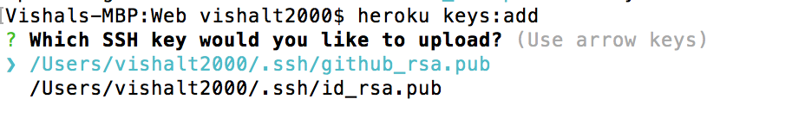

# Create a new app using the heroku web app

1. Go to heroku.com
   1. It should redirect to dashboard.heroku.com/apps
2. Click the new button in the top right
3. Click Create new app

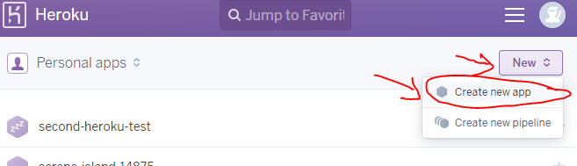

1. Give it a name
2. In the deploy tab, under Deployment Method, click Heroku Git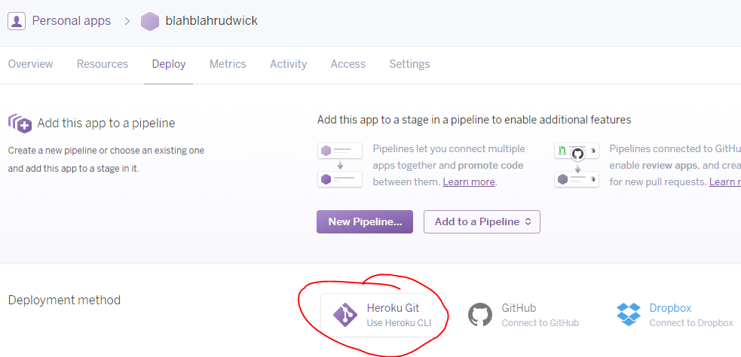
3. You will see further down the page are some git commands. We will be using these.

# Add Composer Files

* Add Composer.lock and Composer.json to your git directory.

# New Repository

* This will link up your local files to your git account on heroku.
* Use Bash for this:

Initialize a git repository in a new or existing directory

$ cd my-project/

**(or whatever your project is named. This should be your web folder)**

$ git init

$ heroku git:remote -a YOUR-APP-NAME-GOES-HERE **(obviously fill in your app name)**

#### Deploy your application

Commit your code to the repository and deploy it to Heroku using Git.

$ git add .

$ git commit -am "make it better" **(in make it better, add a comment.)**

$ git push heroku master